Name: Kevin Benny

USN no: 1941028

Date: 5 Sep’2021

Question: Creation of images with special effects.

* Basic Steps: Dragged and dropped necessary objects.
* Standard primitives used: Box, Tube, Cylinder, Cone, Plane, Geosphere, Circle, Torus
* Edited the objects accordingly.
* Modifiers used: Shell, Rotate, Scale, Snap tool, Boolean, Bend, Edit Poly, Twist.
* Materials: Scanline
* Lights: Standard->Omni

Resulting in a Stunning Food Court

Screenshot:

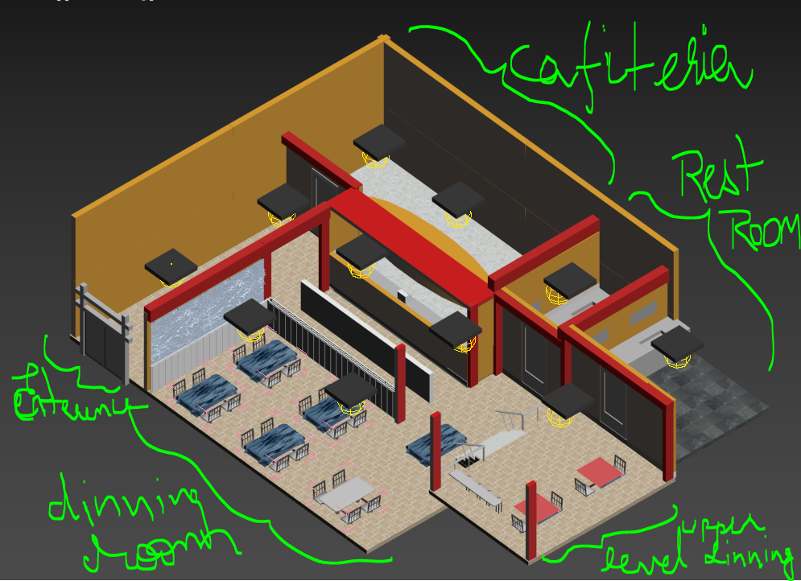

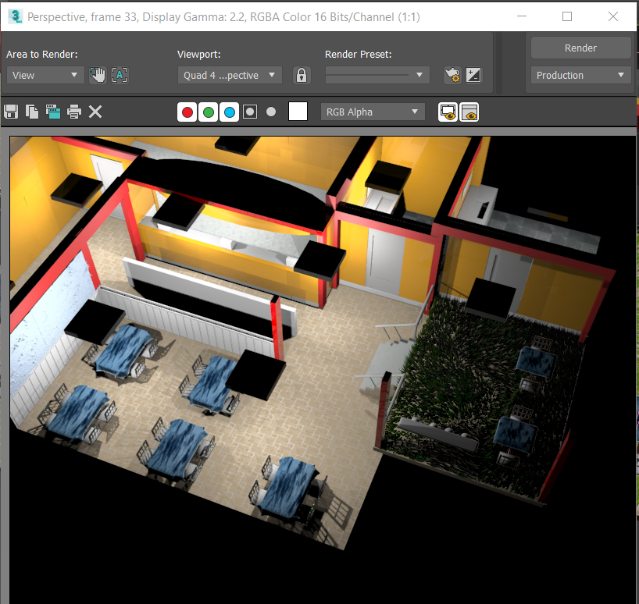RENDERED:

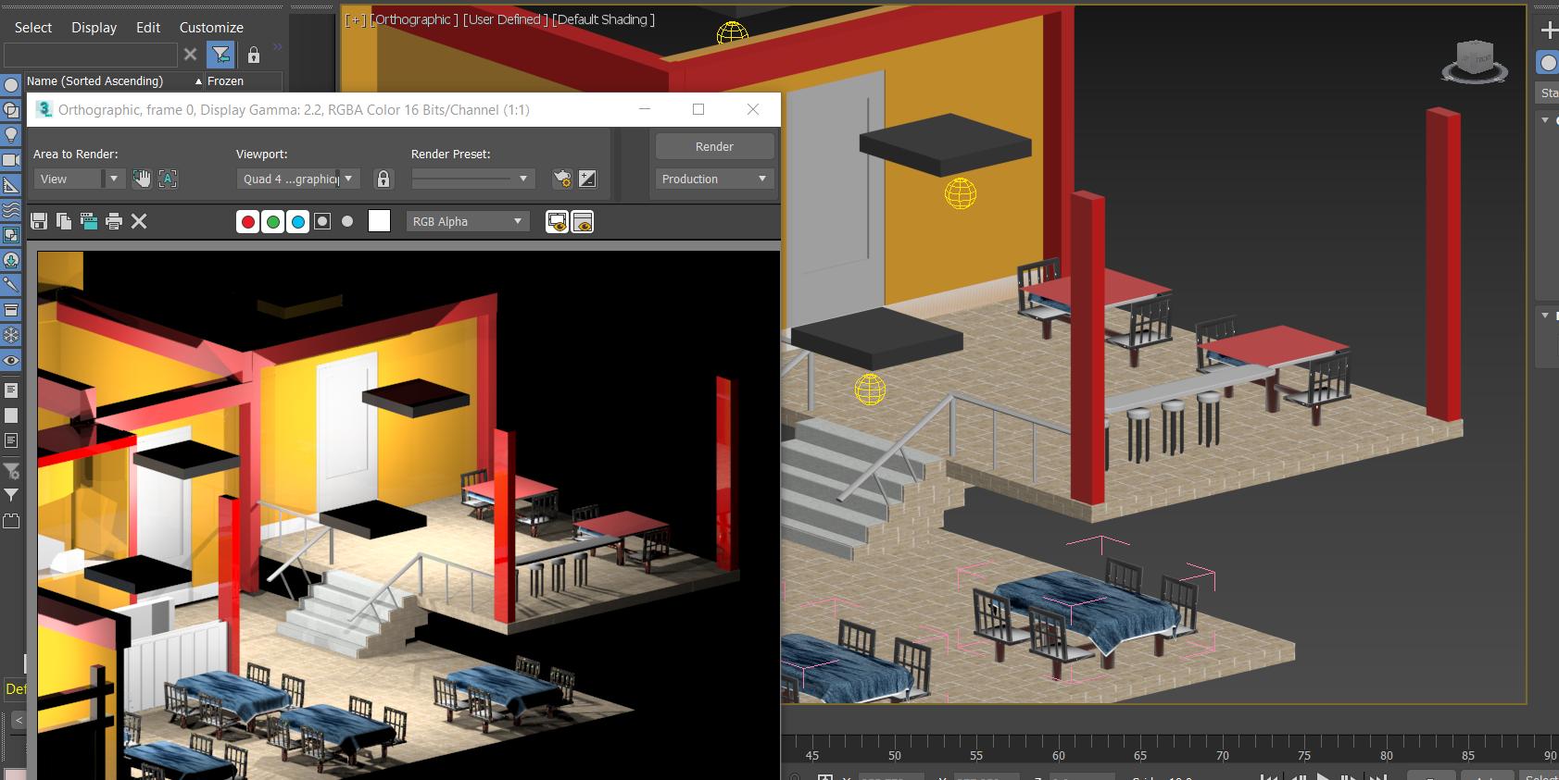

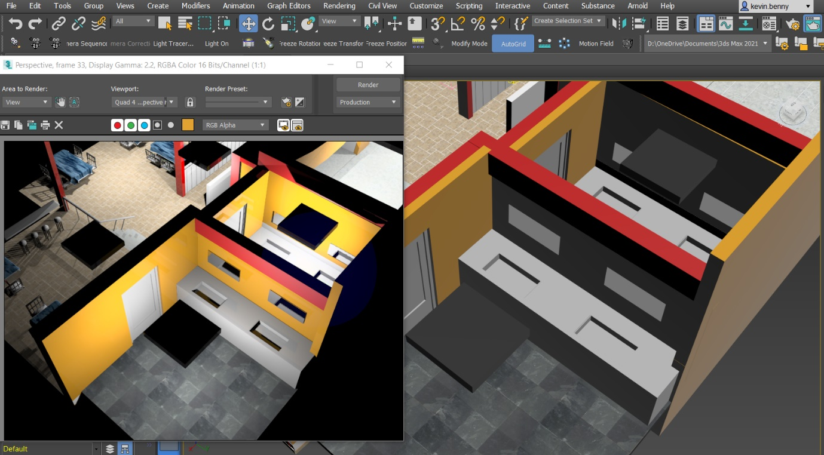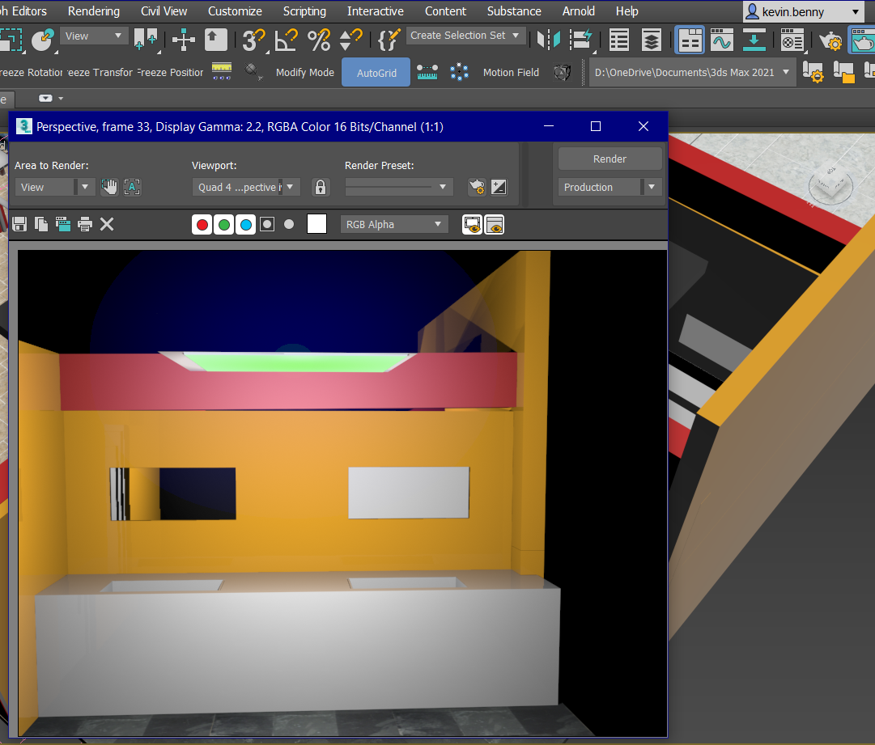

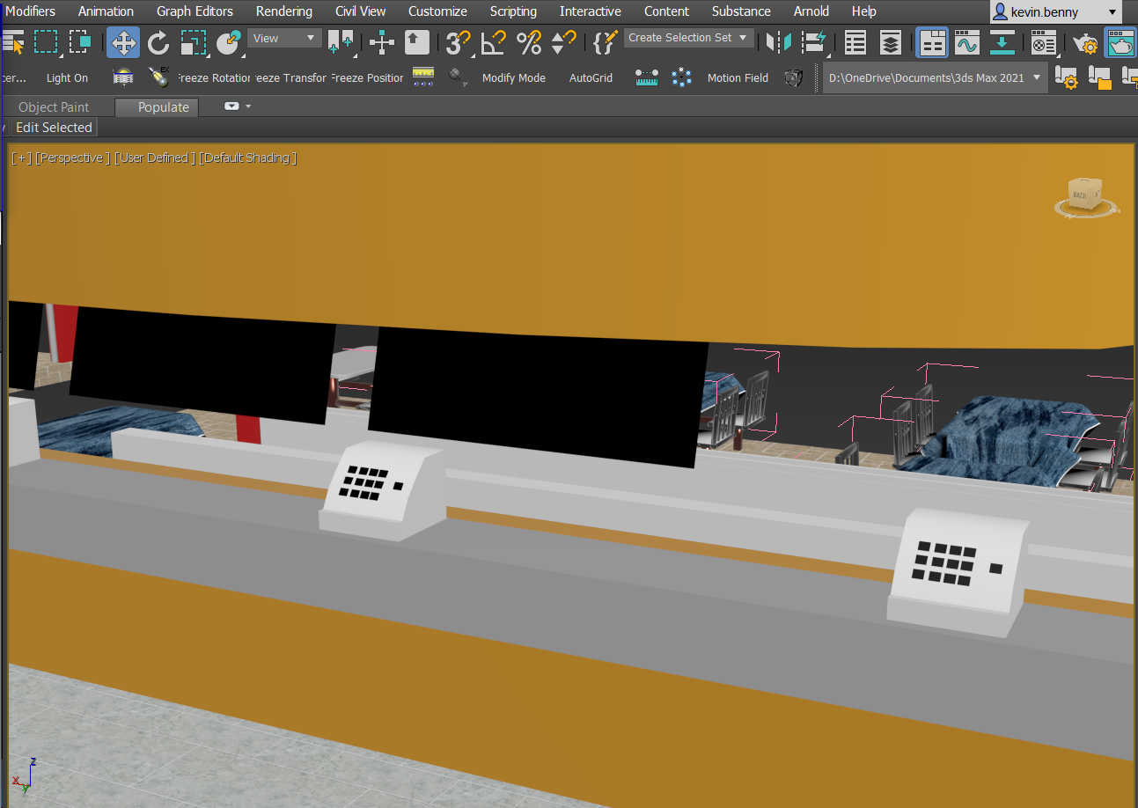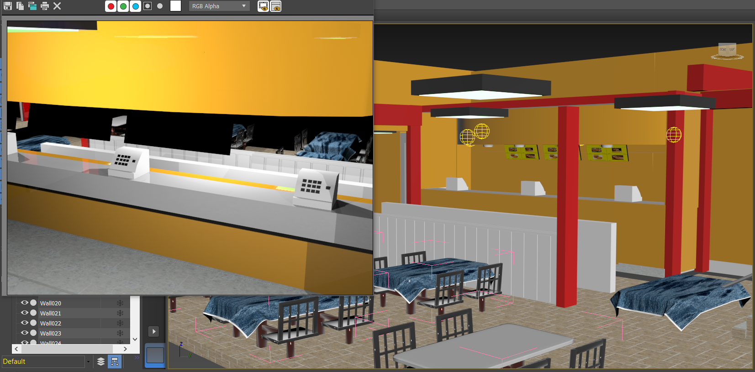

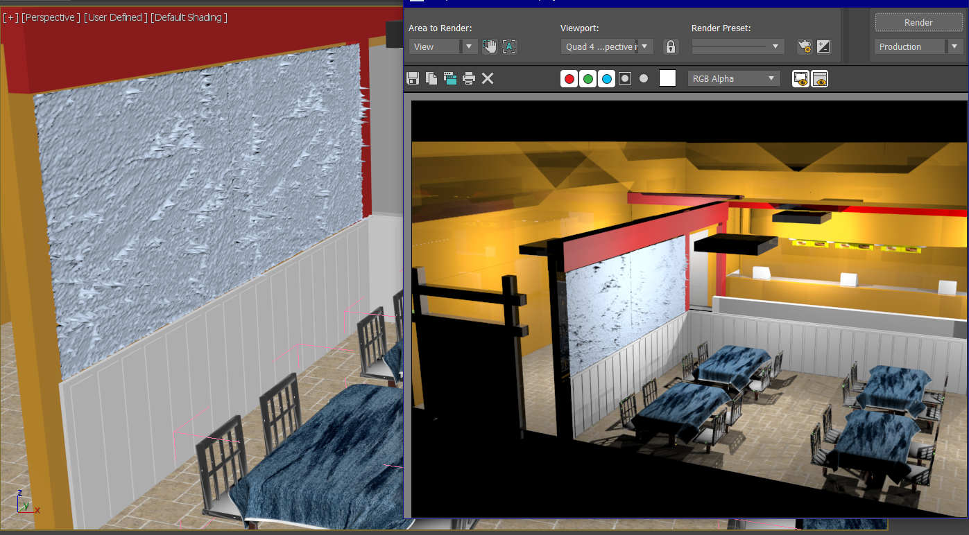

TOP

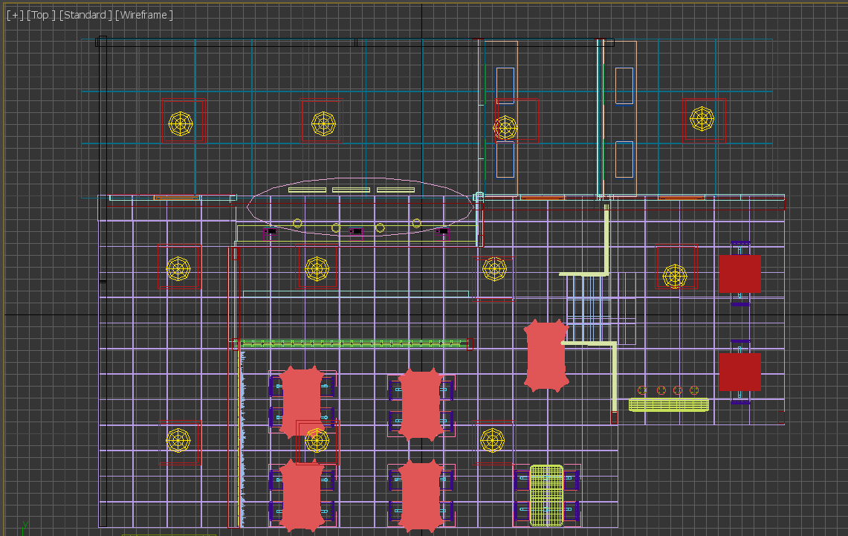

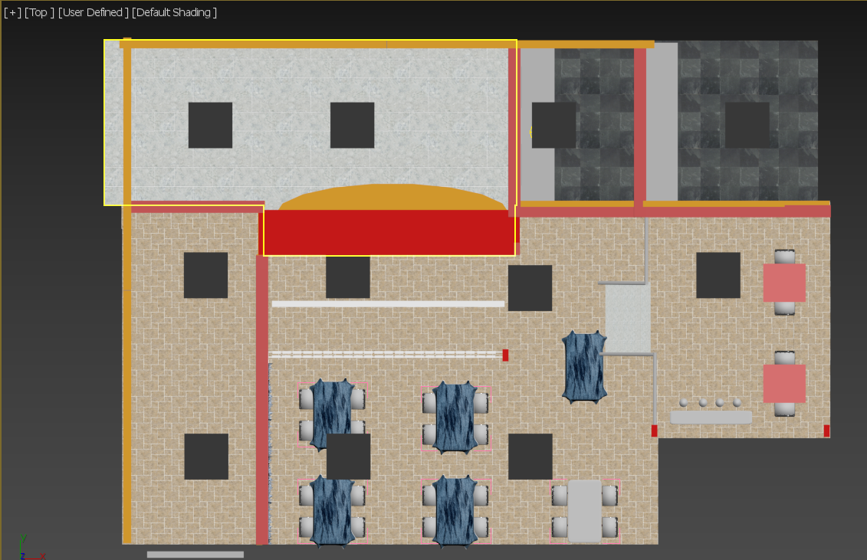

LEFT

